Sample DBQ – American Revolution
AP US History
Mr. Hodgson

Question
Using the documents and your understanding of the Revolutionary War period, analyze the extent to which the American Revolutionary War was truly "revolutionary?"

Document A
The Boston Massacre
By Paul Revere
(C) 1995 --American Antiquarian Society

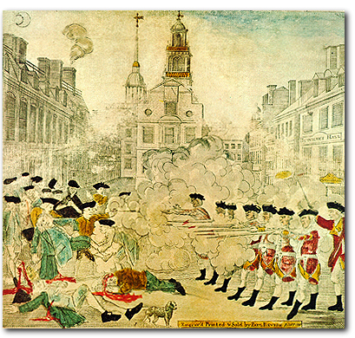

Document B
The Boston Tea Party
By Sarony Major
(C) 1999 National Archives Administration

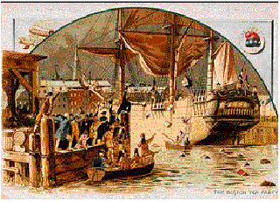

Document C
Treaty of Paris Article V
Written by: D. Hartley, John Adams, B. Franklin and John Jay
(C)1995 --Facts on File, Inc.

It is agreed that the Congress shall earnestly recommend it to the legislatures of the respective states, to provide for the restitution of all estates, rights and properties, which have been confiscated, belonging to real British subjects, and also of the estates, rights and properties of persons resident in districts in the possession of his Majesty’s arms, and who have not borne arms against the said United States. And that persons of any other description shall have free liberty to go to any part or parts of any of the thirteen United States, and therein to remain twelve months, unmolested in their endeavors to obtain the restitution of such of their estates, rights and properties, as may have been confiscated; and that Congress shall also earnestly recommend to the several states a reconsideration and revision of all acts or laws regarding the premises, so as to render the said laws or acts perfectly consistent, not only with justice and equity, but with that spirit of conciliation, which on the return of the blessings of peace should universally prevail. And that Congress shall also earnestly recommend to the several states, that the estates, rights and properties of such last mentioned persons, shall be restored to them, they refunding to any persons who may be now in possession, the bona fide price (where any has been given) which such persons may have paid on purchasing any of the said lands, rights or properties, since the confiscation. And it is agreed, that all persons who have any interest in confiscated lands, either by debts, marriage settlements, or otherwise, shall meet with no lawful impediment in the prosecution of their rights.

Document D
Galloway’s Plan of Union, 1774
(C)1995--Facts on File

That there shall be a new election of members for the Grand Council every three years; and on the death, removal or resignation of any member, his place shall be supplied by a new choice, at the next sitting of Assembly of the Colony he represented.

That the grand Council shall have power to choose their Speaker, and shall hold and exercise al the like rights, liberties and privileges, as are held and exercised by and in the House of Commons of Great Britain.

That the President-General, by and with the advice and consent of the Grand-Council, hold and exercise all the legislative rights, powers, and authorities, necessary for regulating and administering all the general police and affairs of the colonies, in which Great-Britain and the colonies, or any of them, the colonies in general, or more than one colony, are in any manner concerned, as well civil and criminal as commercial.

That in time of war, all bills for granting aid to the crown, prepared by the Grand Council, and approved by the President General, shall be valid and passed into a law, without the assent of the British Parliament.

Document E
First Continental Congress -October 1774

Resolved, That the following acts of Parliament are infringements and violations of the rights of the colonists; and that the repeal of them is essentially necessary, in order to restore harmony between Great Britain and the American colonies, viz.:

The several Acts which impose duties for the purpose of raising a revenue in America, extend powers of the admiralty courts beyond their ancient limits, deprive the American subject of trial by jury, authorize the judges’ certificate to indemnify the prosecutor from damages that he might otherwise be liable to, requiring oppressive security from a claimant of ships and goods seized before he shall be allowed to defend his property; and are subversive of American rights.

Document F
Give Me Liberty Speech by Patrick Henry, 1775 (Letter to the President)
(C)1995 -Facts on File

They tell us, sir, that we are weak; unable to cope with so formidable an adversary. But when shall we be stronger? Will it be the next week, or the next year? Will it be when we are totally disarmed, and when a British guard shall be stationed in every house? Shall we gather strength by irresolution and inaction? Shall we acquire the means of effectual resistance, by lying supinely on our backs, and hugging the delusive phantom of hope, until our enemies shall have bound us hand and foot? Sir, we are not weak, if we make a proper use of those means which the God of nature hath placed in our power. Three millions of people, armed in the holy cause of liberty, and in such a country as that which we possess, are invincible by any force which our enemy can send against us. Besides, sir, we shall not fight our battles alone. There is a just God who presides over the destinies of nations; and who will raise up friends to fight our battles for us. The battle, sir, is not strong alone; it is to the vigilant, the active, the brave. Besides, sir, we have no election. If we were base enough to desire it, it is now too late to retire from the contest. There is no retreat, but in submission and slavery! Our chains are forged! Their clanking may be heard on the plains of Boston! The war is inevitable - and let it come! I repeat, sir, let it come!

Document G
The Radicalism of the American Revolution, by Gordon S. Wood

In the decades following the Revolution, American society was transformed. By every measure there was a sudden bursting forth, and explosion - not only of geographical movement but of entrepreneurial energy, of religious passion, and of pecuniary desires. Perhaps no country in the Western world has ever undergone such massive changes in such a short period of time. The Revolution resembled the breaking of a dam, releasing thousands upon thousands of pent-up pressures. There had been seepage and flows before the Revolution, but suddenly it was as if the whole traditional structure, enfeebled and brittle to begin with, broke apart, and people and their energies were set loose in an unprecedented outburst.

Nothing contributed more to this explosion of energy than did the idea of equality. Equality was in fact the most radicals and most powerful ideological force let loose in the Revolution. Its appeal was far more potent than any of the revolutionaries realized. Once invoked, the idea of equality could not be stopped, and it tore through American society and culture with awesome power. It became what Herman Melville called "the great God absolute! The center and circumference of all democracy!" The "Spirit of Equality" did not merely cull the "selectest champions from the kingly commons," but is spread "one royal mantle of humanity" over all Americans and brought "democratic dignity" to even "the arm that wields a pick or drives a spike." Within decades following the Declaration of Independence, the United States became the most egalitarian nation in the history of the world, and it remains so today, regardless of its great disparities of wealth.

Document H
The Thirteen Colonies in 1763
(C) 1995 --McGraw-Hill, Inc.
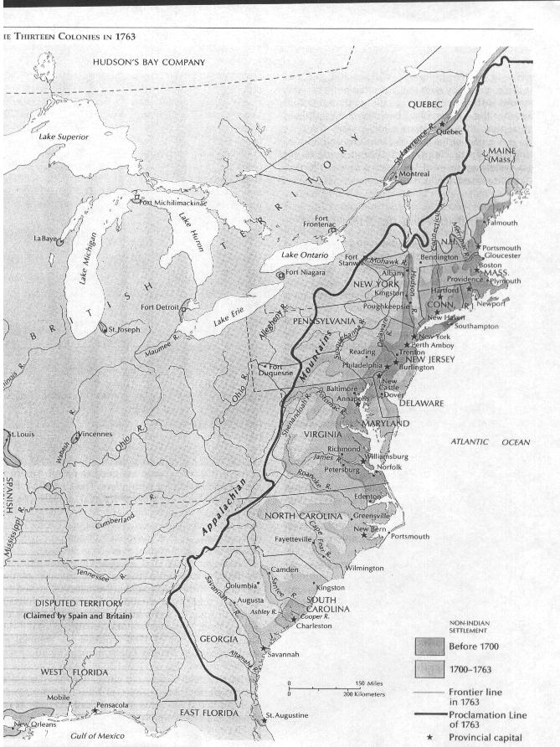
Document I
State Claims to Western Lands and Cessions to National Government, 1782
(C) 1995 --McGraw-Hill, Inc.
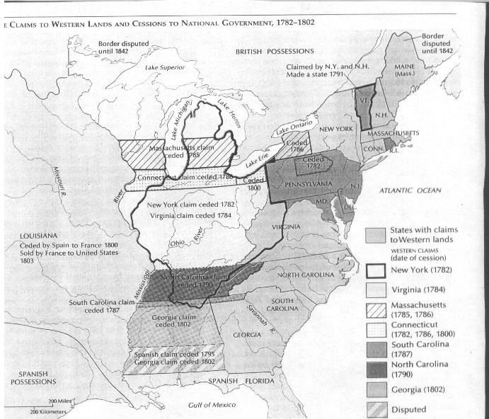

SAMPLE ESSAY
A revolution is an event that forever changes the life and politics of a certain people. These revolutions often have different degrees that they go to, from little change at all to very radical. The Revolutionary War that occurred in the United States is an example of a revolution that was very radical. This war forever altered the social, political, and economic structure of the colonies, illustrating how radical the revolution really was. The American Revolution was actually a very radical revolution that completely changed all aspects of society.

The Revolutionary War was a social revolution because the colonies began to see themselves as interdependent rather than being subject to the will of the British government. The historian Gordon Wood said "The Revolution resembles the breaking of a dam, releasing thousands upon thousands of pent up pressures. There had been seepage and flow before the Revolution, but suddenly it was as if the whole traditional structure, enfeebled and brittle to begin with, broke apart, and people and their energies were set loose in an unprecedented outburst." This completely changed all of the social culture that had existed before the revolution. It altered the complete structure of the relationship between England and America, illustrating how radical the revolution really was. For example in Thomas Paine’s Common Sense he used the metaphor of a satellite that was no more fit to rule the sun than England was to rule the American continent. It didn’t make sense to the people that such a small country like Britain would be controlling them when they were so much larger and so far away. Most of the governors that were in charge of America had never even set foot on the continent. Patrick Henry made an important statement when he said "The war is inevitable--and let it come! I repeat it, sir, let it come!" He is saying that breaking from England is a natural course to follow. The colonists were just obeying human nature in their wants to be independent and self-ruling. For the first time in history the colonists began to think for themselves and unite as one power and stand up against English rule.

The colonists were tired of being used by Britain for monetary gain. They were ready to make major changes in their economic system. This was evident in the engraving of the Boston Massacre done by Paul Revere. The colonists chaffed under the constant array of acts, such as the Stamp Act and the Sugar Act, and went to do the customs houses to protest their oppression. This showed how badly they wanted to change what they considered the unjust taxation that Britain had forced upon them. Another open revolt based on economics was the Boston Tea Party. This was caused solely by what the colonists saw as a tax used only to save an English company. Another example of how greatly the economy was altered was the huge change in the borders of the colonies. Previously, Britain had limited how far the colonists could expand. With the end of the revolution, the colonists rapidly began to expand westward, not stopping until they reached another ocean to hem them in. This change in borders completely altered the entire economy of the colonies. It allowed them much greater land to farm in and also helped their population expand. Not only that, it was a complete break from the Proclamation of 1763 which had set the western border on the colonies. The Boston Massacre and the rapid expansion of the colonies illustrate how much the colonists chaffed under England’s rule and how radical the economic revolution in America really was.

The government of the colonies was also completely altered after the revolution. The complete alteration of the form of government can be seen in Galloway’s Plan of Union. Previously, the colonists had absolutely no say in the election of the Parliament that ruled them. They now had formed a plan that called for the open election of their own ruling body, one that would not be affected by the Parliament in England. This illustrates what a complete reversal the governing style that the colonists had gone through. Another example of the political change that the colonists experienced were the resolves passed by the First Continental Congress. This departure from previous governing style can be seen when the Congress said, "The several Acts which impose duties for the purpose of raising a revenue in America, extend powers of the admiralty courts beyond their ancient limits, deprive the American subject of trial by jury, authorize the judges’ certificate to indemnify the prosecutor from damages that he might otherwise be liable to, requiring oppressive security from a claimant ships and goods seized before he shall be allowed to defend his property; and are subversive of American rights." The colonists also feared the power of Parliament as was stated in the Declaration of the Causes and Necessity of Taking up Arms. This said that there had to be some limiting of the power that the government could hold over an individual. These complete departures from the previous governing style that England had used illustrate how radical the political revolution that occurred in America really was.

The structure of America was forever changed by the Revolutionary War. This was exemplified socially by things like Thomas Paine’s Common Sense, and the radicalism of Patrick Henry. The desire for economic change was illustrated by The Boston Massacre and the Boston Tea Party. And the change in political life was demonstrated by things like Galloway’s Plan of Union, and the resolves of the First Continental Congress. The revolution in America was actually very radical, with their belief that "you can’t let the tail wag the dog."

